**Create an ansible shared library in jenkins for your tool with the following steps:**

* clone
* User Approval
* Playbook Execution
* Notification

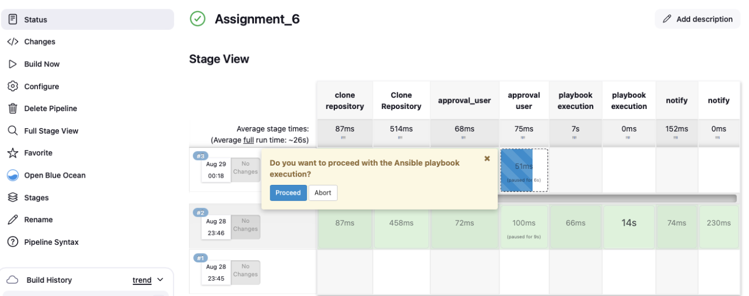

## Playbook Execution

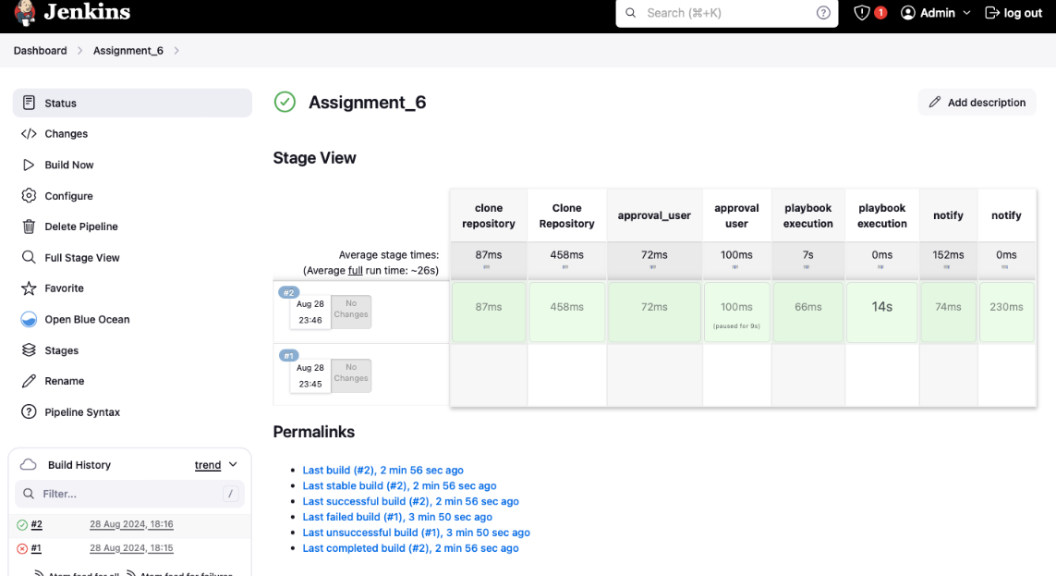

Notidication

